Ticket: IM9733397
Fixed Asset test case:
Discerption:
The Cigna Fixed Asset report is not correct for certain FEB-17 assets. Total depreciation and YTD depreciation is incorrect. The data appears to be in the database, but it is not presenting in the report - now showing on the expected prime. Appears to have prime join issues.

Current Cigna Fixed Asset Report without Prime and with multiple assets no:
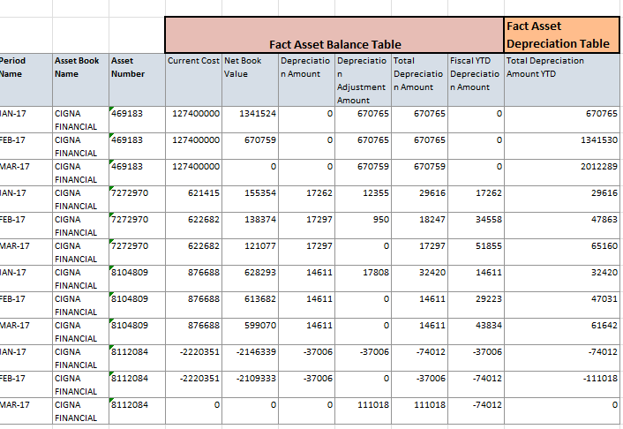

New Cigna Fixed Asset Report with Prime and new logical column Total Depreciation Amount YTD:
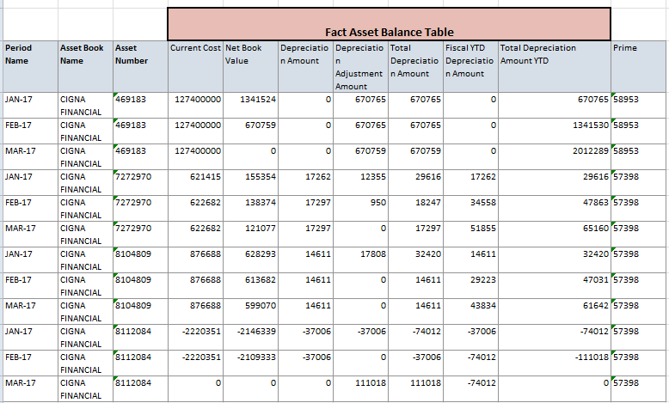
Cigna-Fixed asset report with Prime:
Total Depriciation amount and Total Depriciation amount YTD Columns selected from Fact-Depreciation table
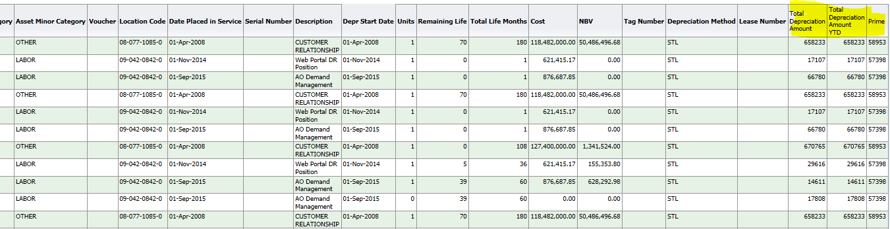
Without Prime:
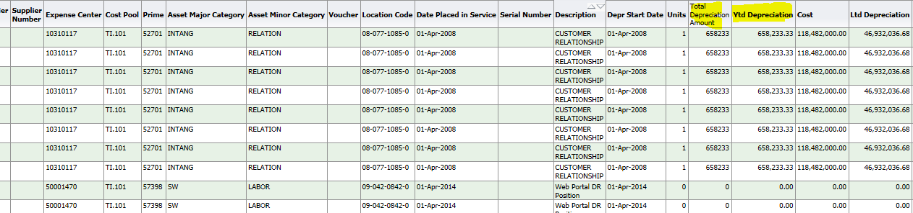

New Cigna Fixed Asset Report with Prime and new logical column Total Depreciation Amount YTD:
Test Reults:
